Linux Programming : Assignment-9
Name : Vigneshwaran P
Class:3C
USN : ENG24CY0069

21. Write a shell script using if…else to check if a number is even or odd.
Soln:
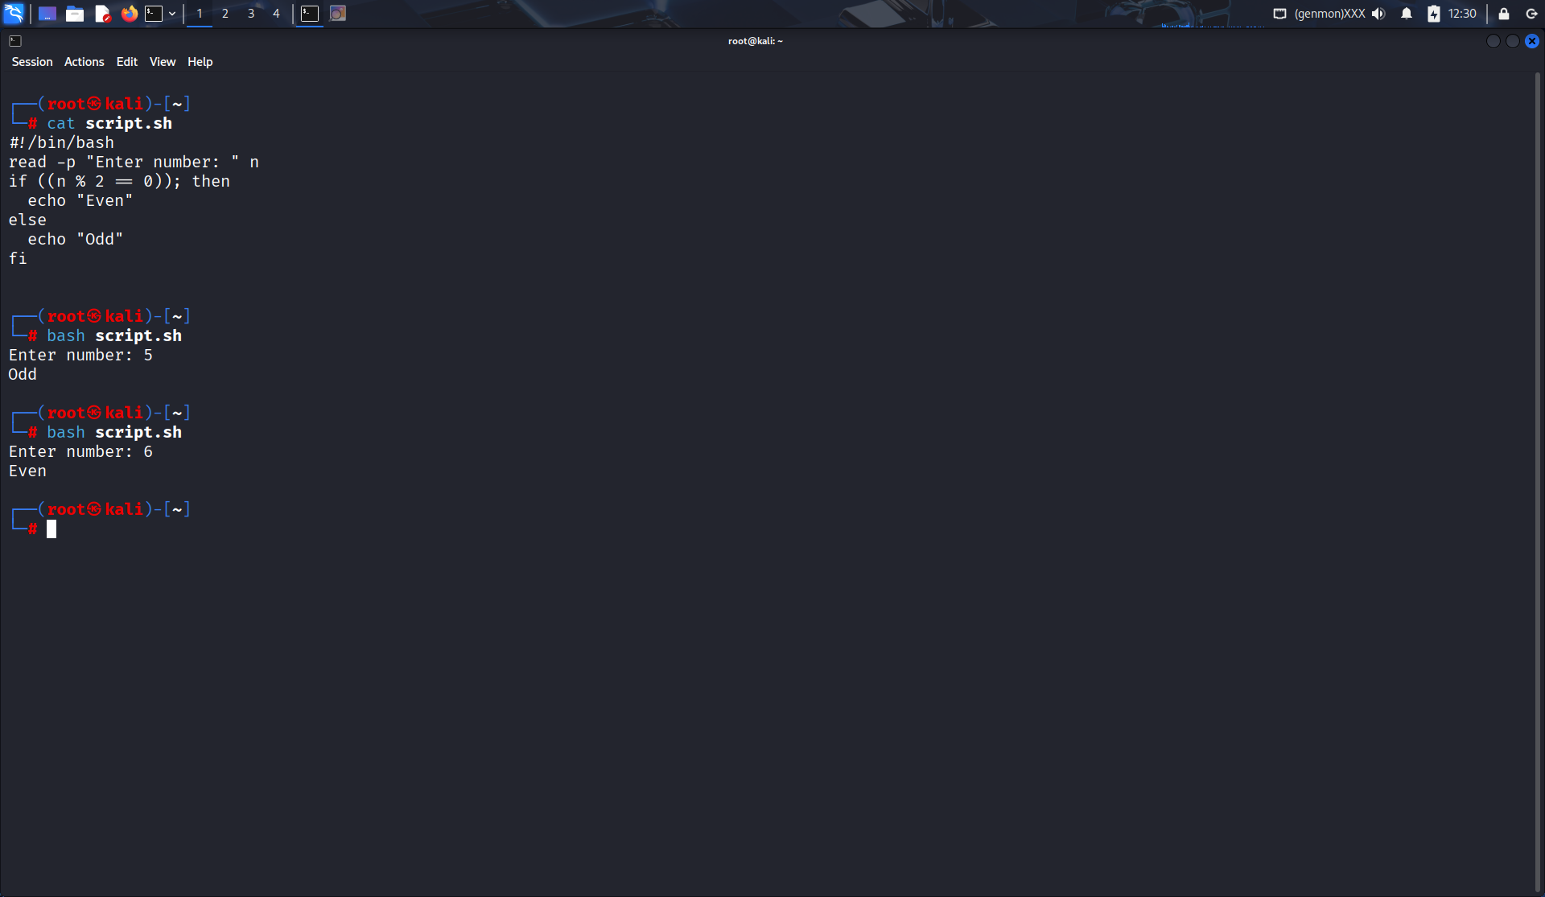

22. Explain the difference between if and case statements in bash.
Soln:
if → for condition checking
case → for matching multiple patterns
Example:
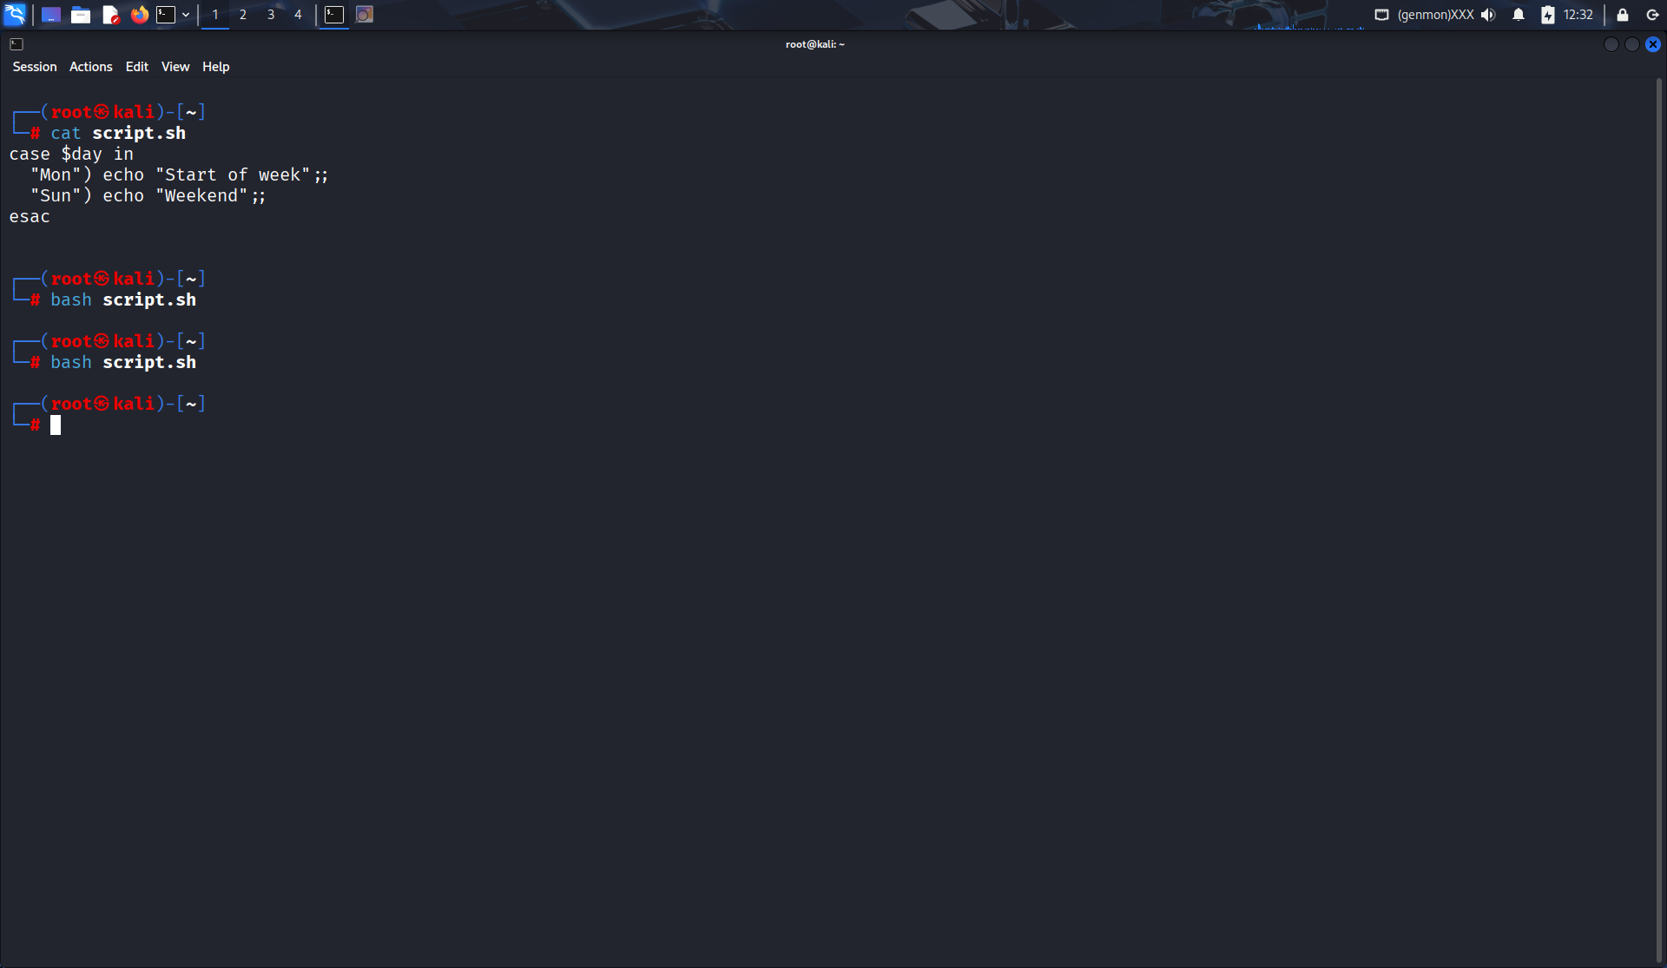

23. Write a script to find the largest of three numbers entered by the user.
Soln:
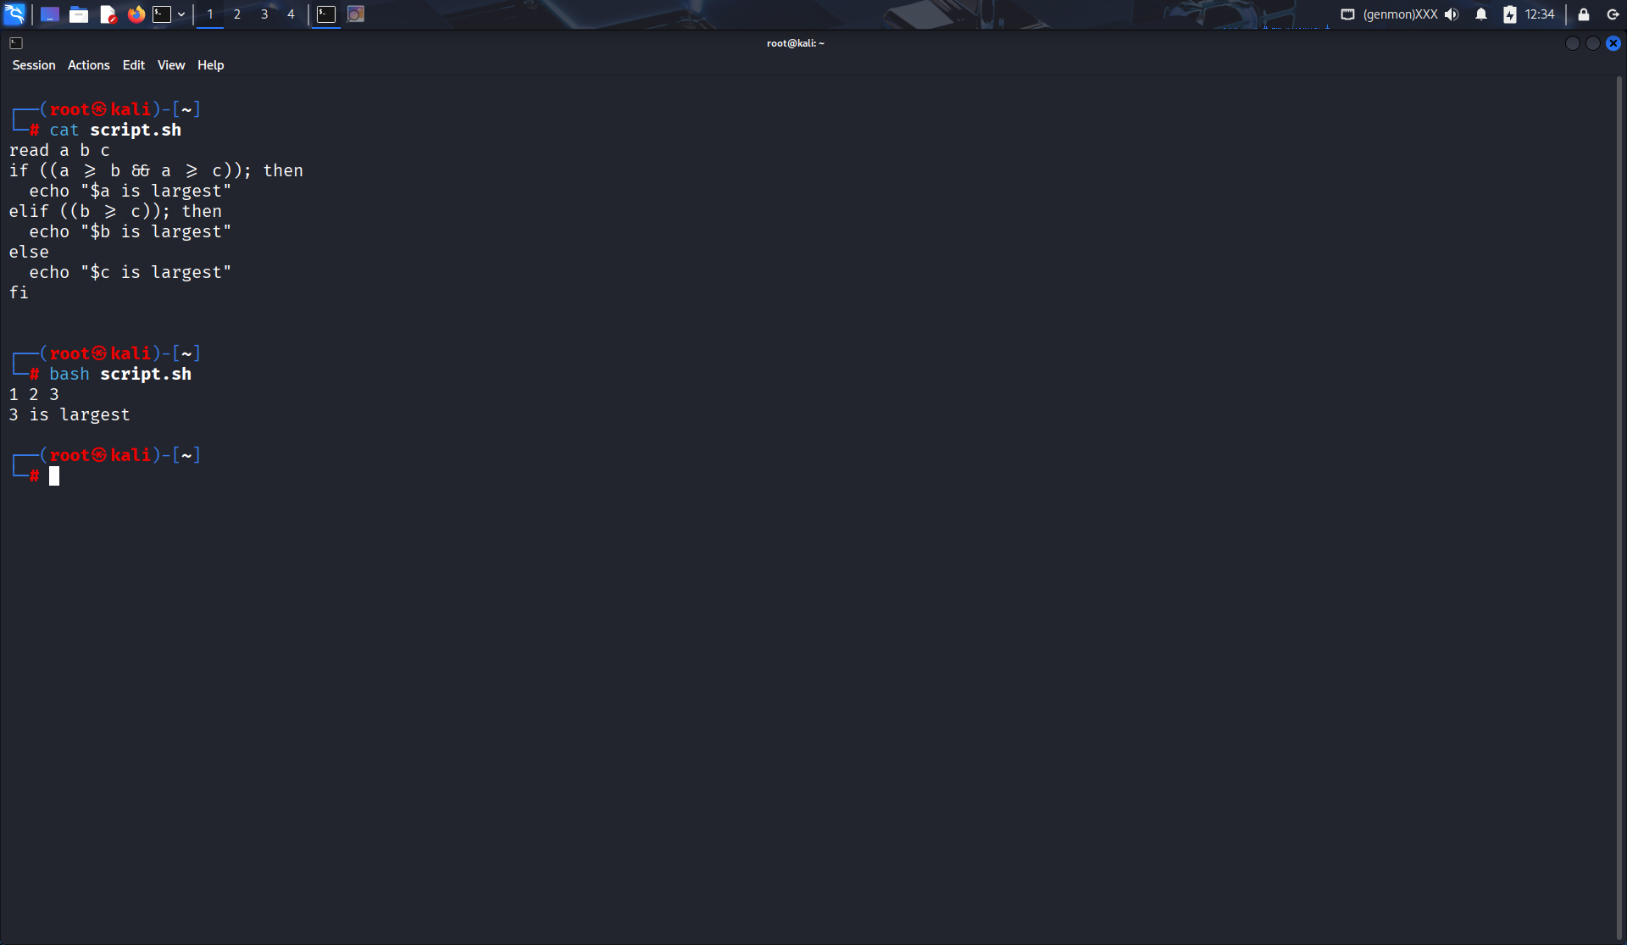

24. How do you use a for loop to traverse an array in bash? Give an example. The array is defined as arr=(123, “Abs”, -2.3, ‘A’, 23.56, 0).
Soln:
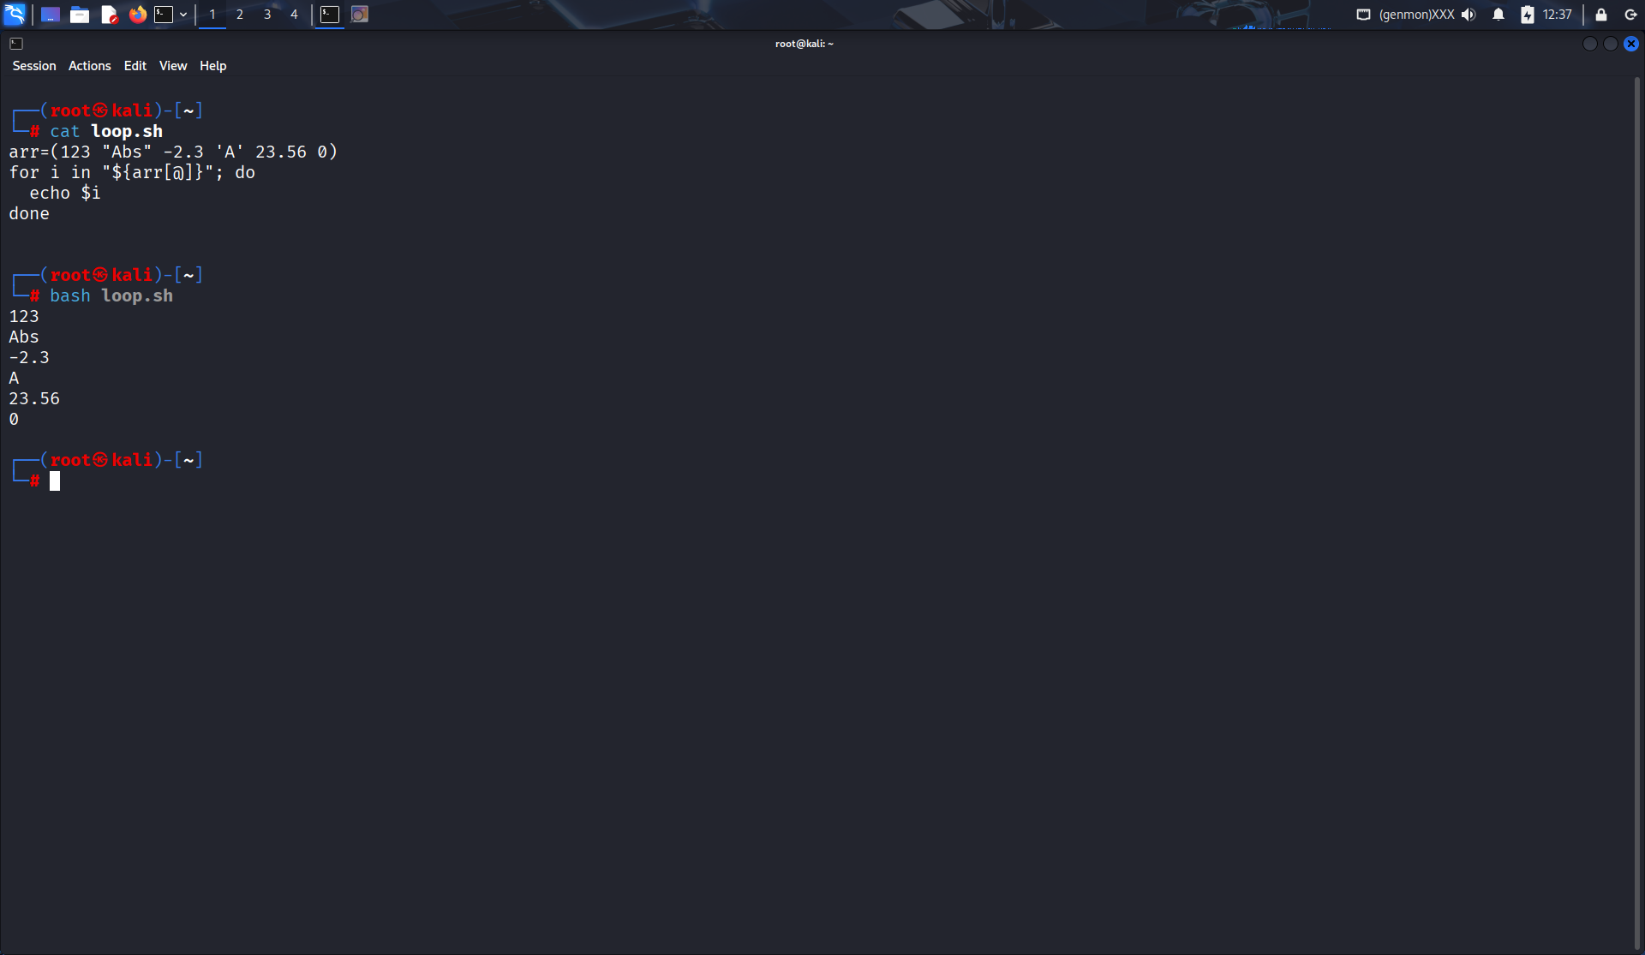

25. Write a shell script to loop through all files in the current directory and display their names.
Soln:
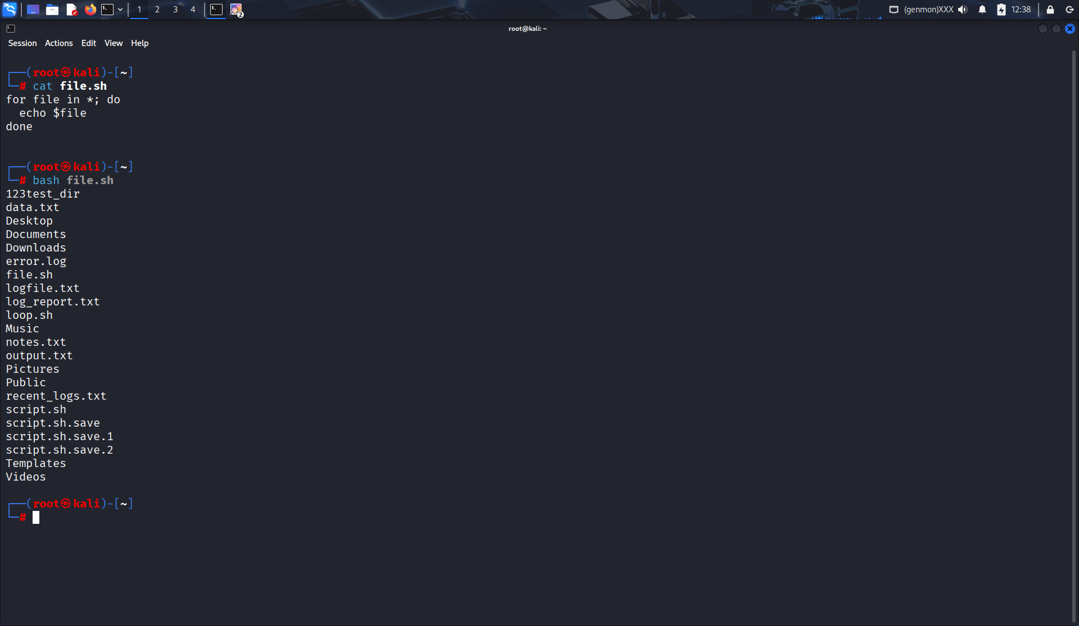

26. What is the difference between while and until loops in bash?
Soln:
- while: runs while condition is true
- until: runs until condition becomes true

27. Write a countdown timer script using a while loop.
Soln:
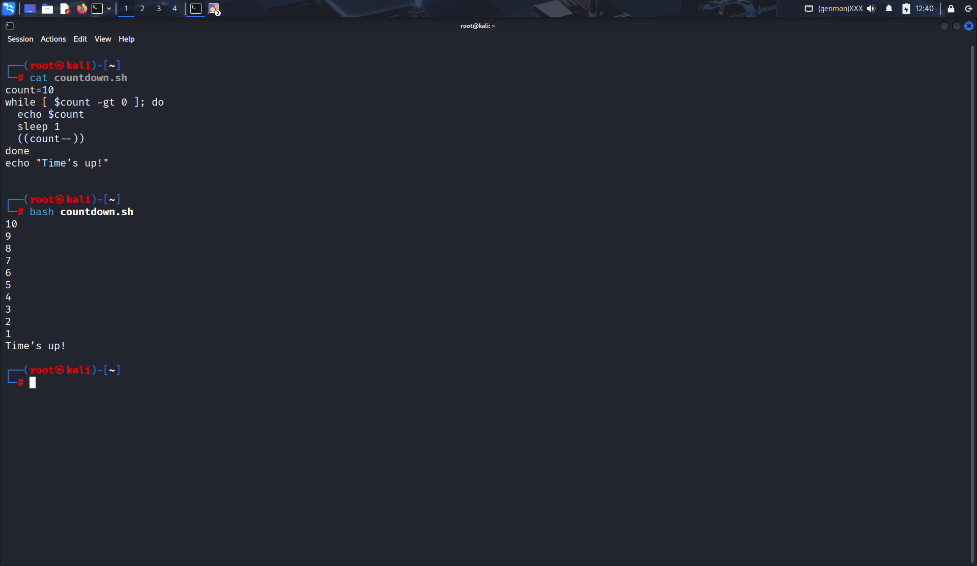

28. How do you use break and continue statements in loops? Give examples.
Soln:
Example of break and continue:
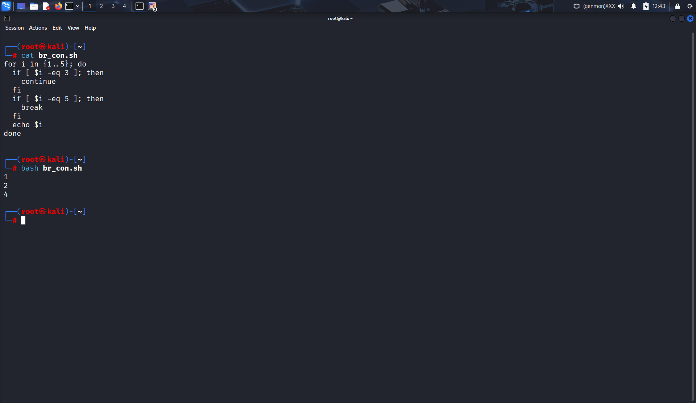

29. Write a script to check if a file exists or not using the if and else loop
Soln:
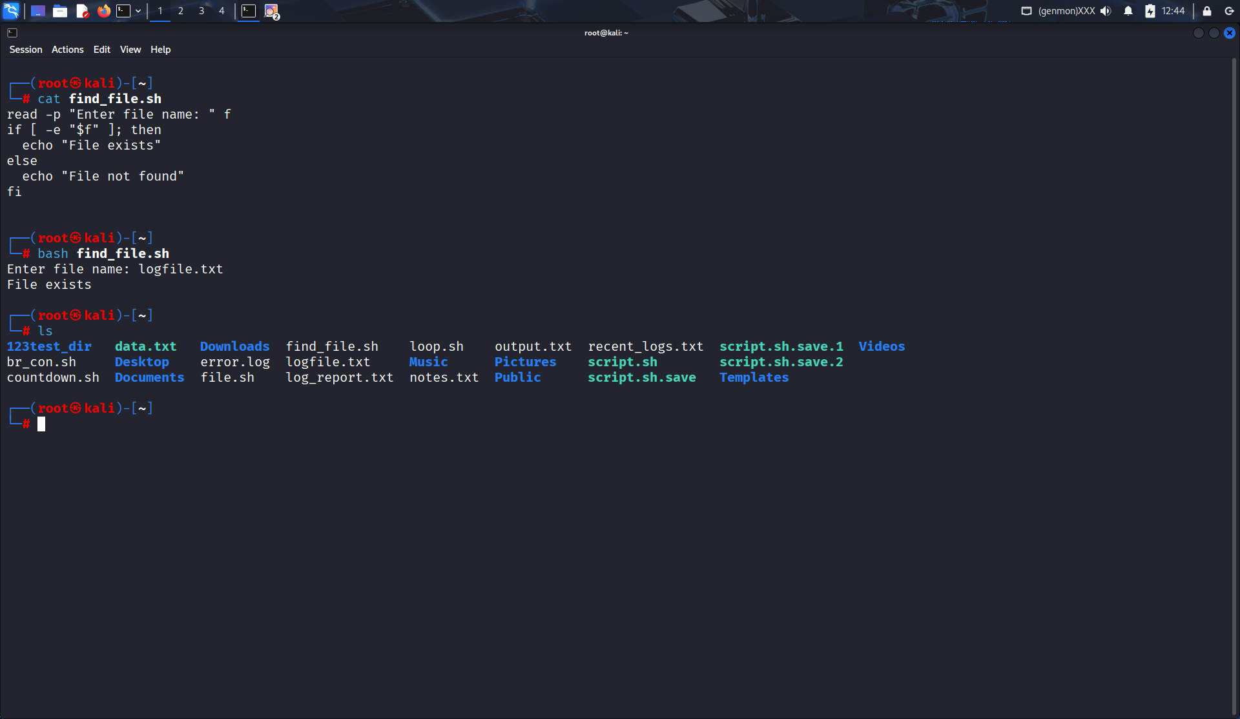

30. Write a script to calculate factorial of a number using for loop.
Soln:
